Discourse community
Topics to discuss-
How to be a broke college student:
- 1. Wait to get books - Syllabus Val)
- 2. Where to get books (nicole)
- 3. Keep supplies simple (Val)
- 4. Buy textbooks used from students (Johanna)
- 5. Pack lunches and snacks (nicole)
- 6. Free transportation shuttle and carpooling (Johanna)
- 7. Use free resources (Madeline)
- 8. Save on electronics, rent from the library(Madeline)
- 9. Free sporting tickets offered to students (mackenzie)
- 10. Apply for scholarships and grants (mackenzie)
College doesn't come cheap. There's many tricks of the trade that poor students go on without knowing about. Here are ten broke student hacks to help pinch pennies and keep as much of that change in your pocket as possible.
- Wait to Get Books
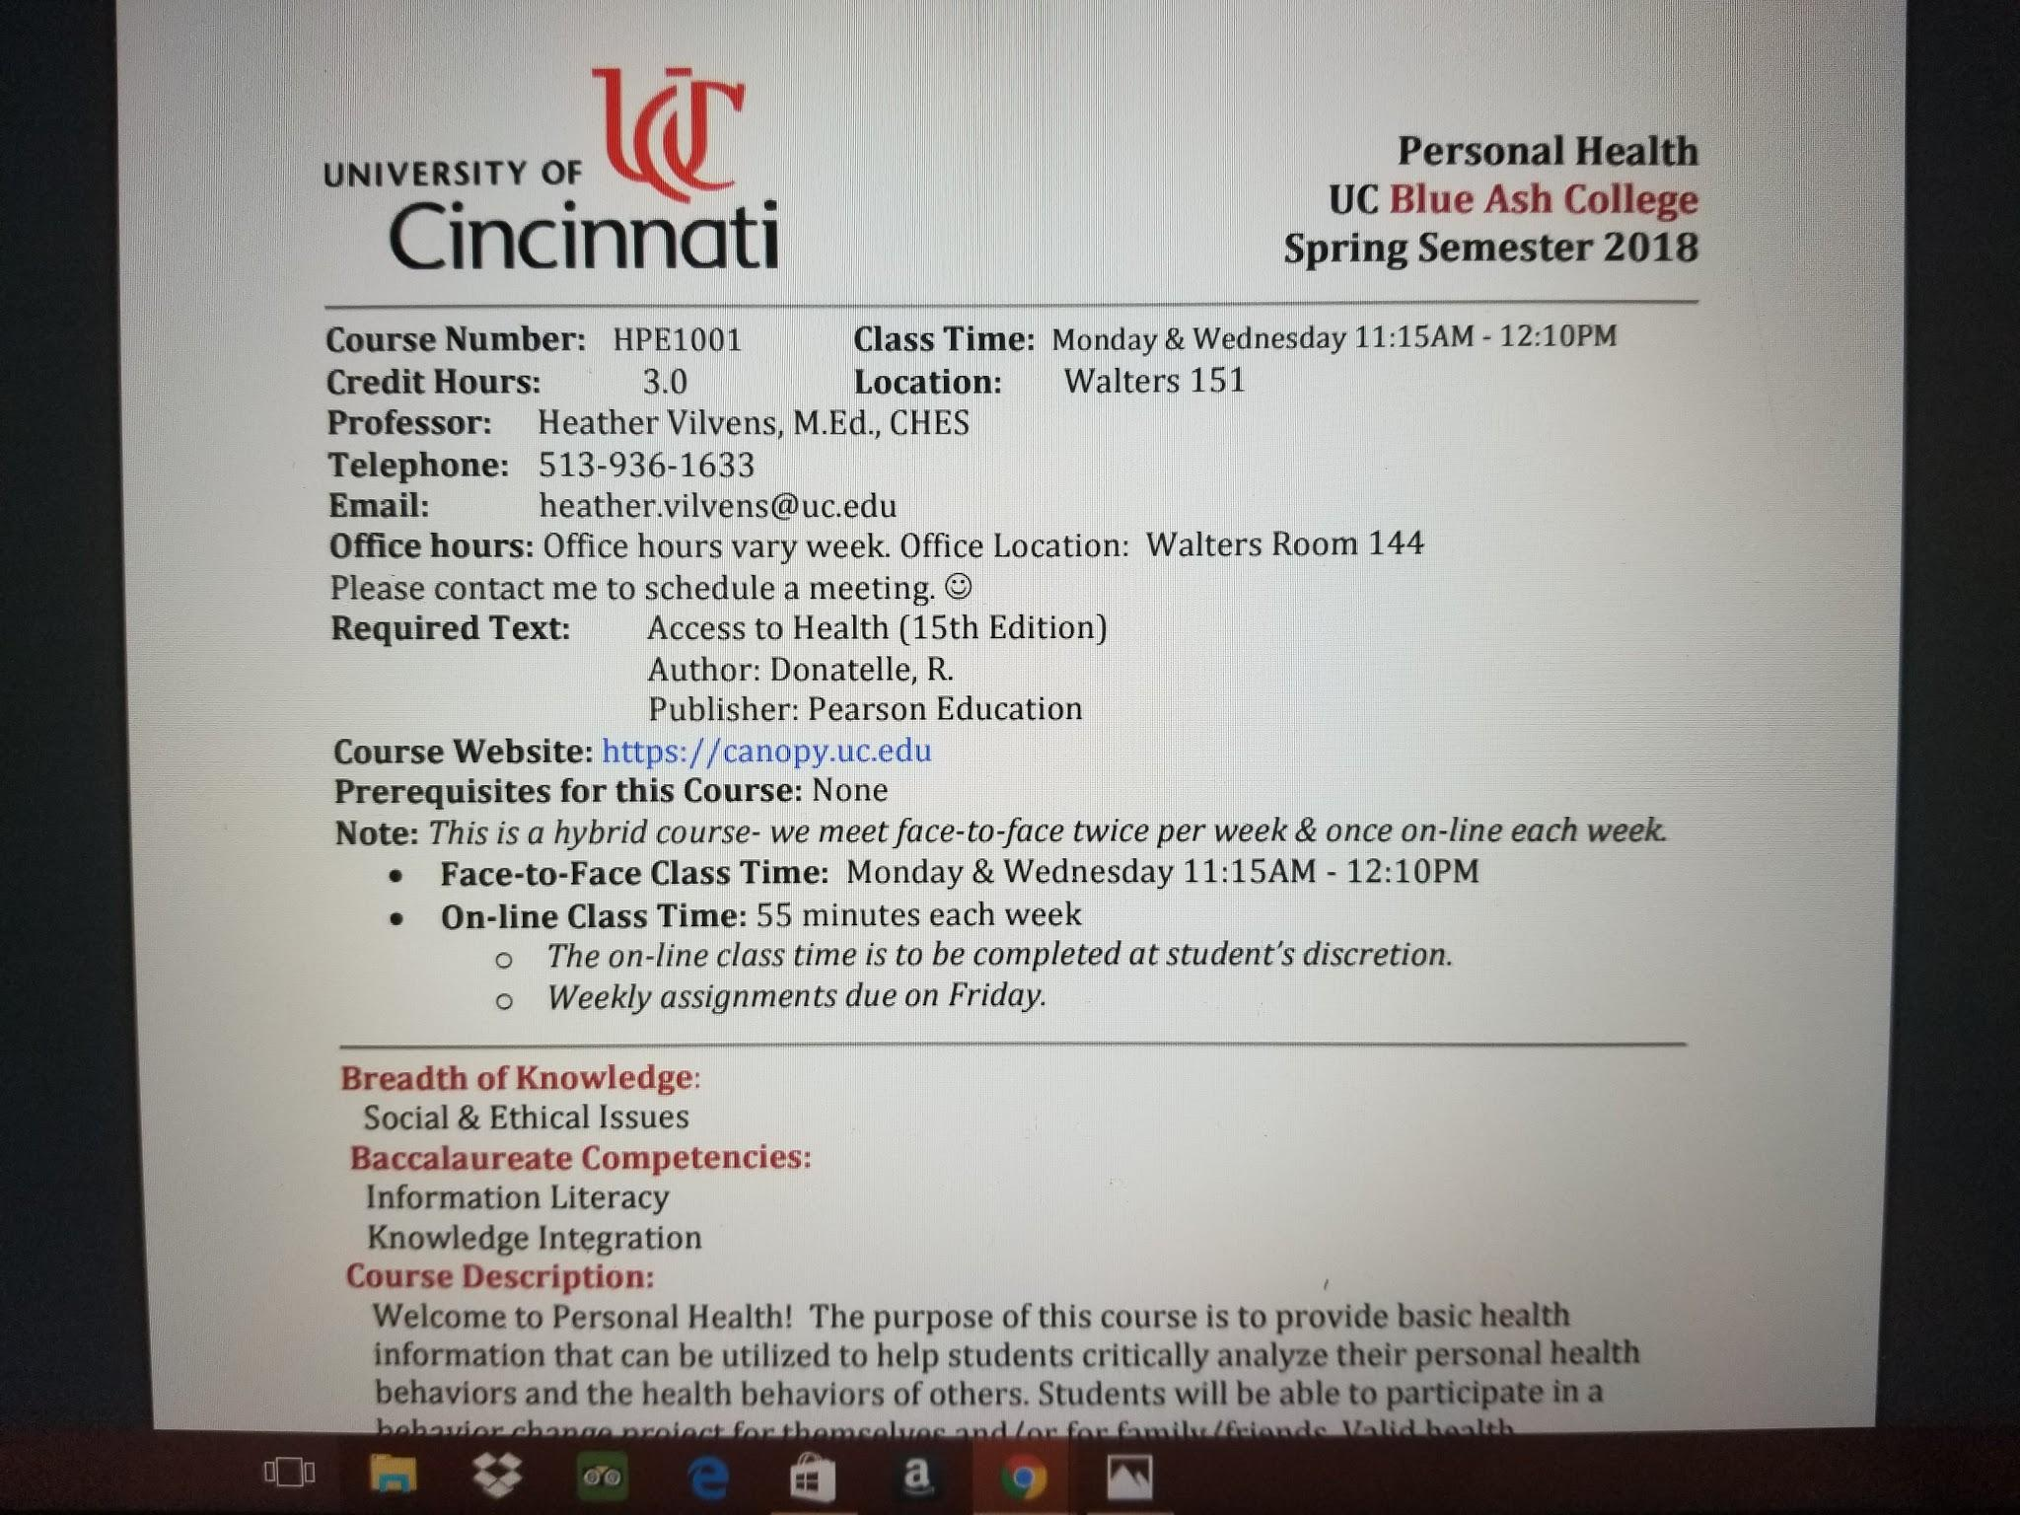
Wait to hear from professor to see if there are alternatives to the book. There may be an older version that works just fine. In some cases, very rarely, professors will have readings posted on blackboard and you won’t have to spend a dime!
2. Where To Get Textbooks
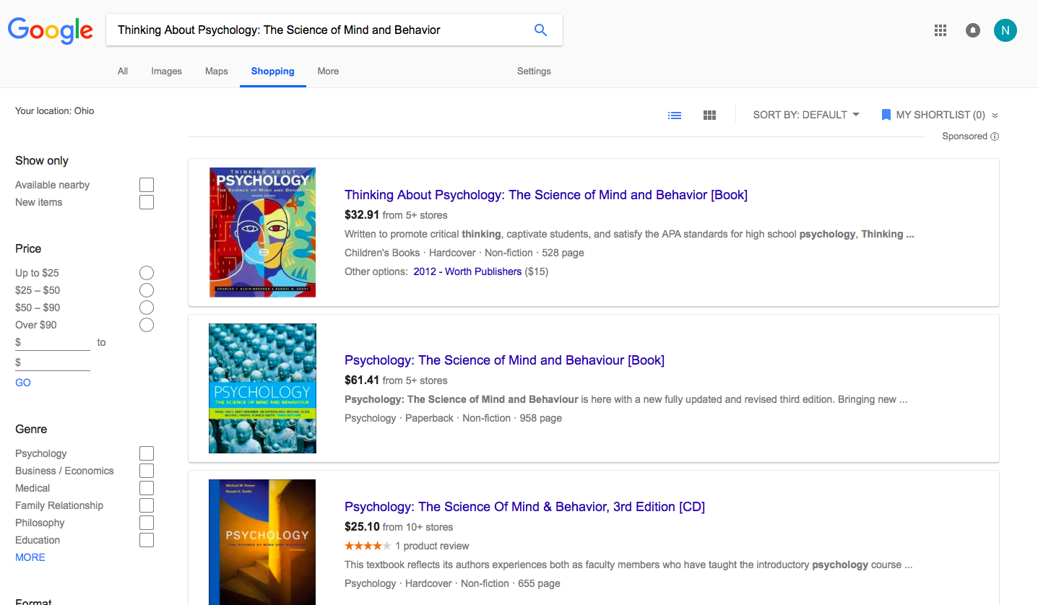
If you go to google and type in the textbook you are looking for and click on the shopping tab, you will get a whole list of places that you can get the textbook from. Some of the options they give you are Barnes and Noble and Amazon. This is a lot cheaper than buying the books from the campus bookstore because most of the textbooks there are more than half the price of the books that you can buy online.

3. Keep Supplies Simple
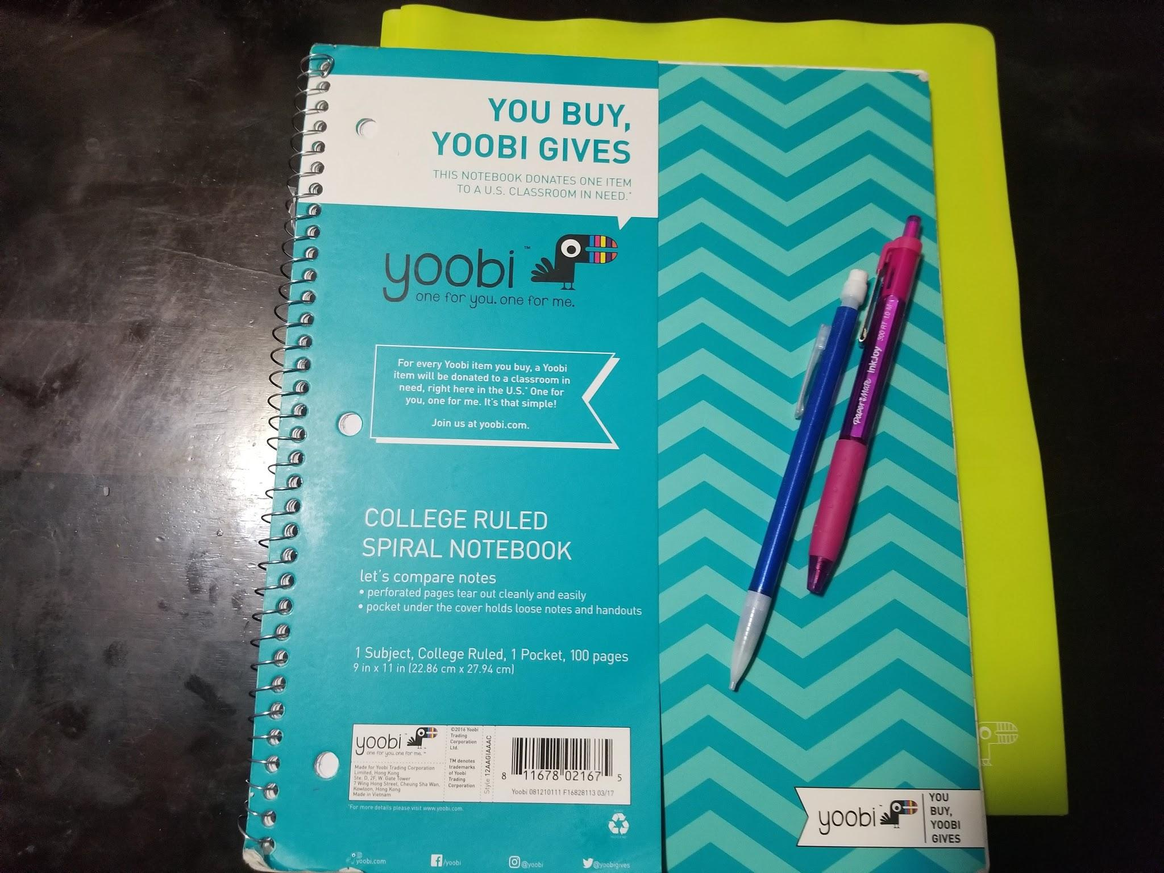
When it comes to school supplies, you may already have them laying around the house. Check for pens and pencils, maybe even an older sibling may not be using an old calculator anymore. If you’re staying in a dorm check out thrift stores or garage sales for home essential items.
4. Buy Used Textbooks From Students
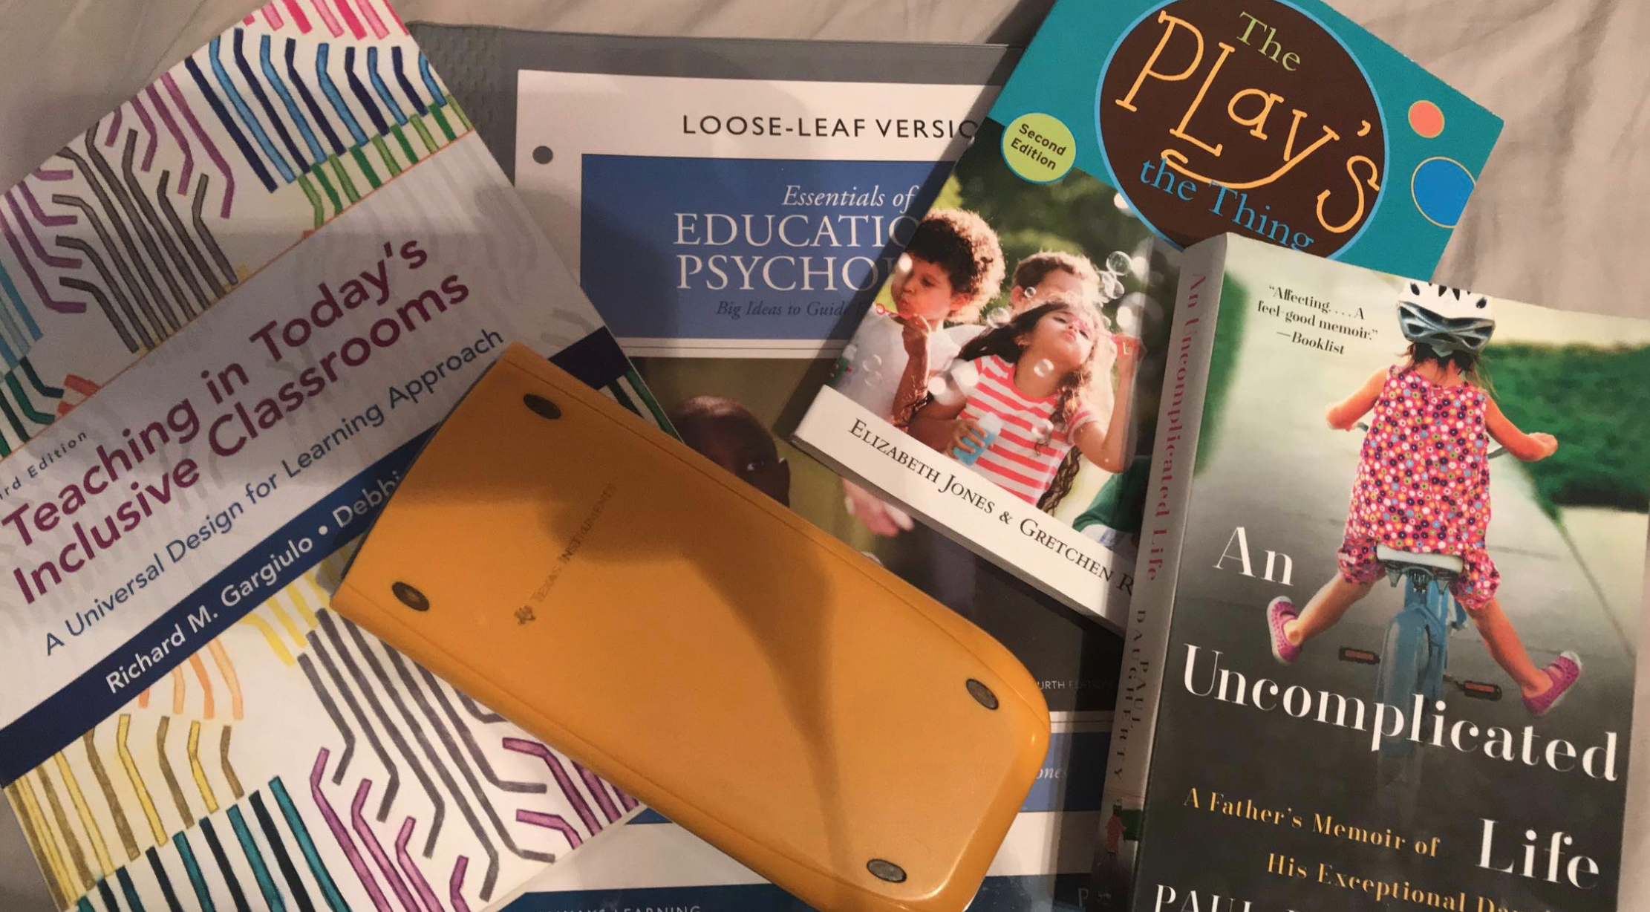
Textbooks are not cheap and not very useful after you finish your class, so why not sell them to other students? It’s a win win for both students. If you buy your textbooks you will mostly never use it again, so sell them! It will save you a lot of money buying used textbooks.

5. Pack Your Lunches
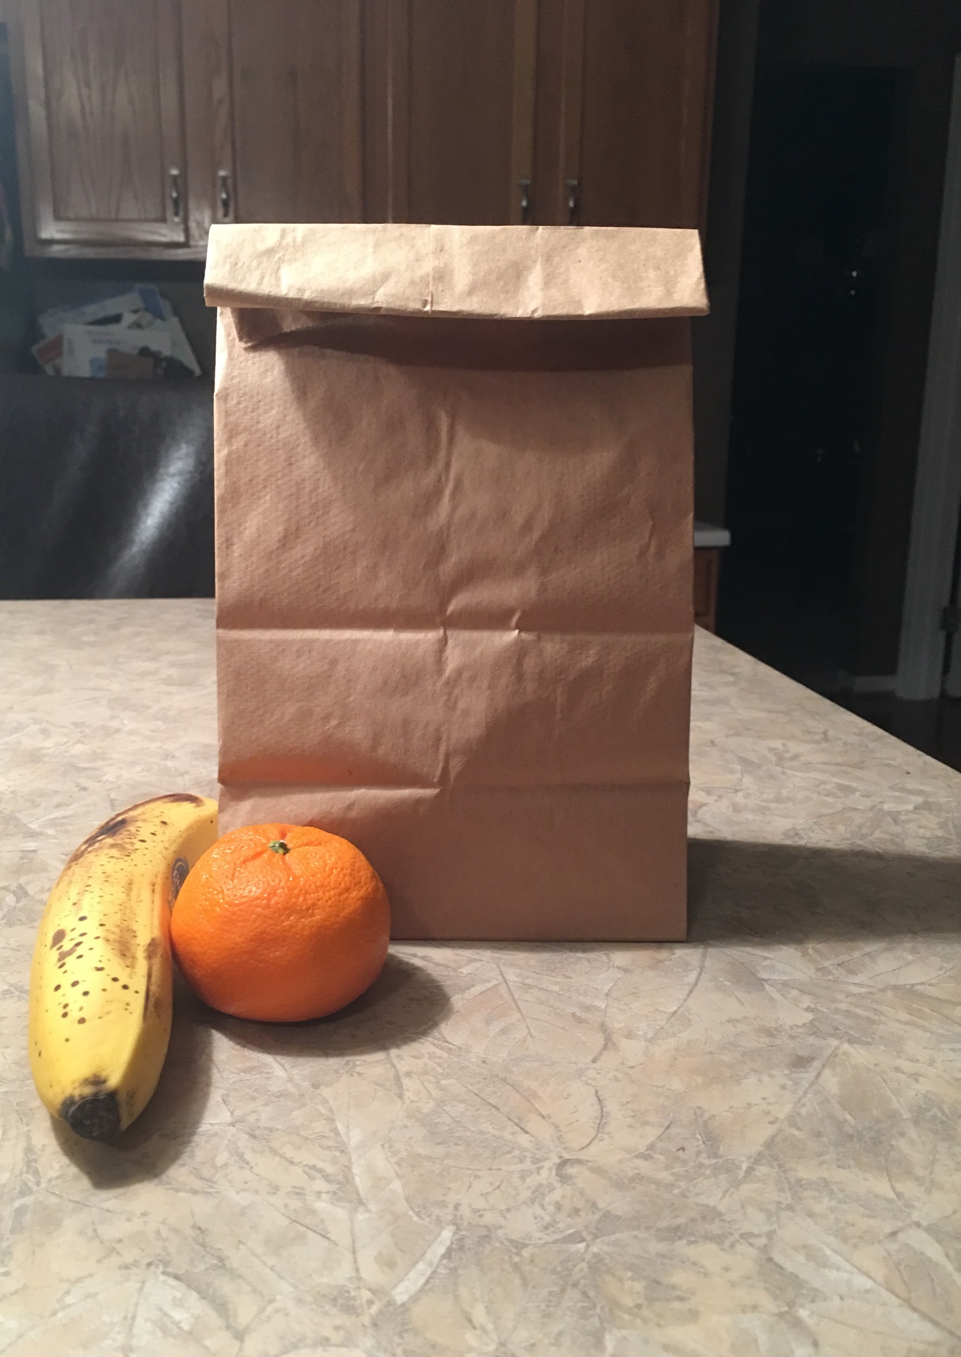
Buying a lunch everyday can really start to add up. A nice way to save your money is to start packing your lunches instead of buying them in the cafe or somewhere else. It may seem like a pain to do this, but you will really start to see how much money you actually spend when you are buying a lunch everyday.

6. Free Transportation
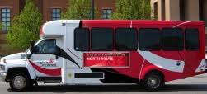
UC provides free transportation from main campus to Blue Ash this something to take advantage of if you live on campus. If you do not live on campus you could save money by carpooling. Gas is not cheap so any way to drive less can help save.

7. Use Free Resources
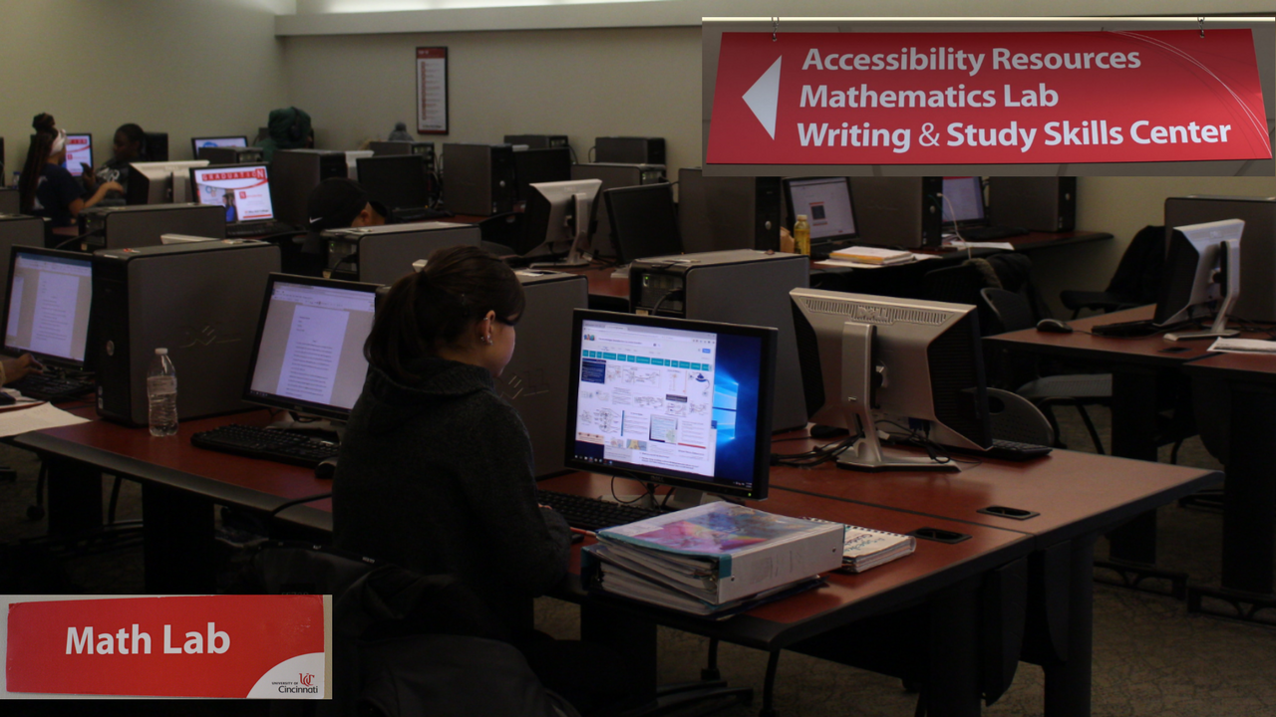
Academics are priority numero uno for all UCBA students. Tuition is expensive, but included in the academic courses a student is paying for, comes the free resources located all over campus. Rather than spending hundreds on private tutoring and online subscriptions to academic aid courses, visit the free academic resource centers located on campus!
8. Save on electronics, use the Library!
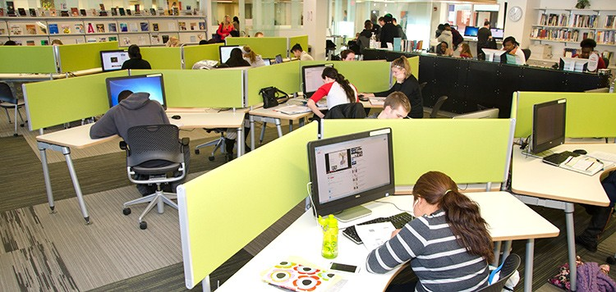
There is an unspoken rule that college students “must” own a laptop. This is completely untrue. Our UCBA library gives students access to computers, printers and copiers, not to mention the option to rent laptops, headphones, and electronic chargers! All a student needs a free bearcat card and the access to these free electronics is limitless!

9. Free Sporting Tickets
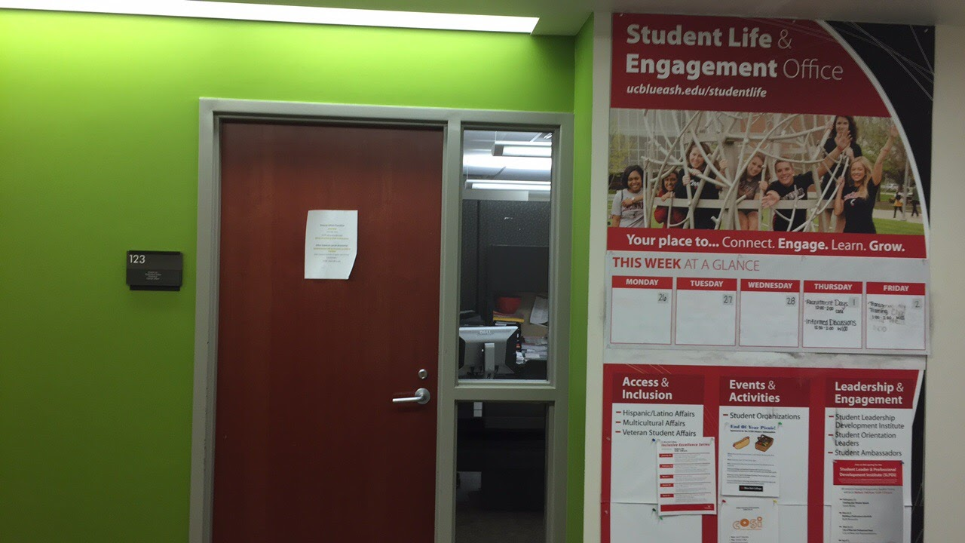
Tickets for UC football games and other sporting events can be expensive. Luckily for UC Blue Ash students, the Student Life Office (Muntz 123) offers one free ticket per student for games when you show them your UC ID. For each game, they hang up a sign outside of the office advertising that students can get their free ticket, but if you want to go to a game go to the Student Life Office ASAP because tickets run out quick.

10. Apply for Scholarships and Grants
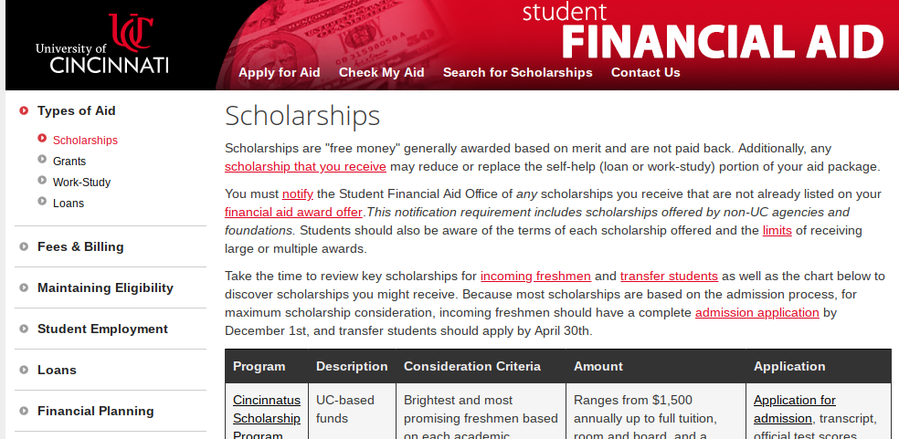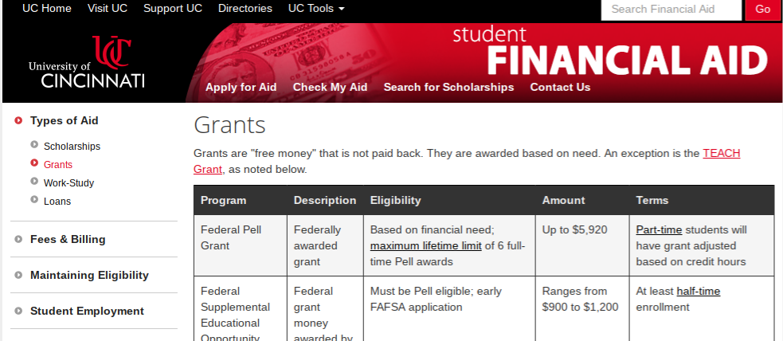
It’s no shock that college costs a lot of money, even at a satellite campus. UC offers many different scholarships and grants for eligible student on their website. You can also go visit the one stop office and ask for help looking into scholarships and grants that can help lower the amount of money you have to pay back.

