Johanna Schoster
Professor McLaughlin
Intermediate Composition (006)
1 March 2018
Genre Analysis
What is genres? A class or category of artistic endeavor having a particular form content, technique or the like (Genre). Genre is divided into categories based on similarities. Genres can be divided into many sub-genres
How is genre defined? Genres are both social and cognitive this means the text is socio-cognitive schemas that can be reformed for different context. Genres are purposeful, or at least, responsive. When writing it should have meaning. Is the author trying to inform, entertain, or persuade the audience? Genres are named by those in power or by the writer’s purpose. Genres are clustered or grouped. Grouping depends on the research backgrounds. Genres are conventional. When a genre is conventional it is a genre that is familiar writing or reading style. Genres vary considerably in terms of prototypically. When reading or writing one genre it is similar to others in that genre, but not always the excite same (Johns).
How does genre affect writing? Academic writing refers to a style of writing researchers use to define the intellectual boundaries of their disciplines and their specific areas of expertise. Academic writing main purpose is to inform the reader. In most cases academic writing is done by a researcher in their specific area of expertise or they do the research to become an expert on the topic. In most cases the audience is a teacher, professor, classmates, or anyone interested to the topic. Most academic writing has several sources or the writer conductus their own research. When the writer has sources or provides their own research it gives there work credibility. Most academic writing is in MLA or APA formatting depending on what is required. With these formatting type they tell you the font size, font type line spacing, and margin size. If your academic writing is an assignment, it will be graded by the professor. With an academic paper you must provide a work cited page and in text citations to give credit to others work. Ever academic paper varies, but these are the most common genre awareness of academic writing.
Journalistic writing is the work of finding, creating, editing, and publishing news, or material written and presented for a newspaper, magazine, or broadcast new source. The purpose of journalism is to inform readers or viewers, but with the upraise in social media there is false journal with the purpose to entertain the audience. The role of the writer can be interviewer or researcher. The audience of journalistic writing depends on the topic. The audience of this kind of writing is very large because it is broadcast through newspaper, television, social media, radio, and magazines. Journalism writing does not have to have sources, but should be creditable. Journalistic writing should follow the format of the publisher. The publisher also decides the font type and size. Journalism should be your own work and credit should be given if outside sources are used. It should also be unique so the audience is increased to read the article. Journalism has many sub genres so this only applies to journalism as a whole.
When comparing academic and journalistic genres, it is difficult to compare without specific academic and journalistic writings. This is because even if two pieces of writing are the same genre, does not mean they have the same affect, content, length, tone, and so on. All genres are made up of sub genres. To do a genre analysis of academic and journalistic writing I have chosen an academic journal called New Technology in Schools: Is There a Payoff? And website article called 10 Reasons Today’s Students NEED Technology in the Classroom. These two writings how similar topics, but are completely different genres.
This academic journal purpose is to inform the reader about the effect of computers in school while the purpose of the online websites is to inform you on ten reasons why students need technology in the classroom. Both of these articles have the purpose to inform, but why? The journalistic article comes from a website called securEdge networks. This website is for teacher and is to inform them on all thing technology at school. While the academic journal is a study on if there is a payoff from new technology.
The role of the of the writer is very different in this academic journal then in the website. The writers of the academic journal are Stephen Machin, Sandra McNally, and Olmo Silva. These writers served as research’s and experts on if there is payoff for new technology in schools. In academic writing there is often more than one writer this is because the content of the material is much more precise, detailed, and longer. The writer of the website article Danny Mareco who is an expert in technology. Mr. Mareco does not have a background in importance’s of education just technology. This means that these are his ten opinions of why children need technology in the classroom. These writers are sharing different roles because some are sharing facts while the other is giving their opinion.
The audience of the two different genres are very different. The website article was very easy to find and by a google search reasons for educational technology. This article could be for teacher, administrators, or parents. On the other hand, the academic article is much harder to fine. It can be found on the University of Cincinnati data base summon. To have access to this data base you must be a student or teacher at this University. The website had a much broader audience because it is much easier to find.
These two articles are extremely different when it comes to sources. The academic journal had over 50 sources. The journalistic article does not have any sources. The journalistic article is based off of opinions and there are not any outside sources. On the other hand, the academic journal is mostly facts from other outside sources with additional input from the authors. These two different genres require different sources.

The format for these articles have some similarities, but are also very different. Both the journalistic articles and academic journal use numbers to layout the format. The one sub-genre to journalism list. In a list you use numbers to separate each idea. Most of the time these articles have a number in the title that tells you have many are going to be in the list. For example, the journalistic article 10 Reasons Today’s Students NEED Technology in the Classroom. This title shows that it is a photo caption list and the format is going to be numbered.
Numbering is not a common format in academic writing. The numbering format helps the reader distinguish the different topics and ideas. This format could be a writer’s preference or it could be the publisher’s requirements. 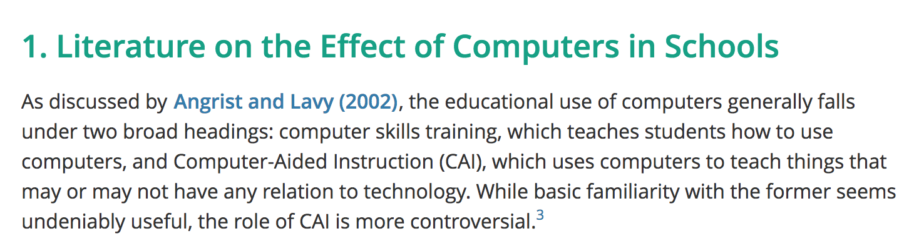
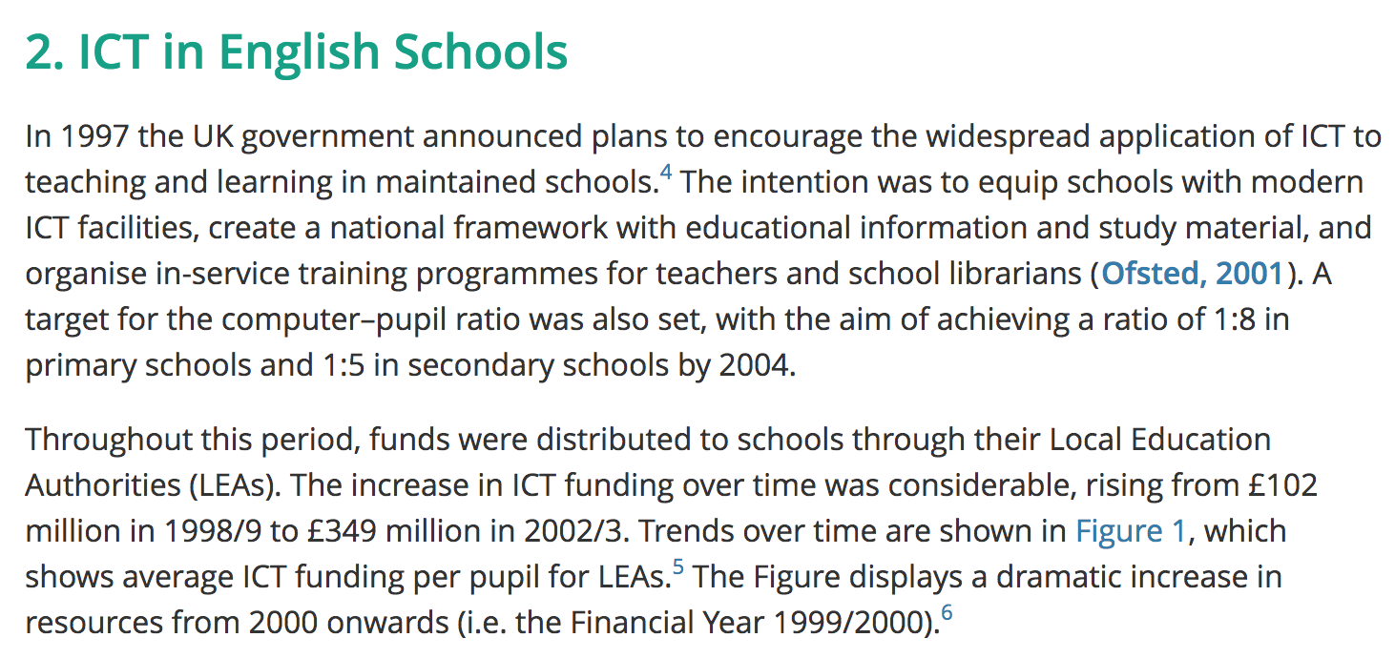
Both of these images show how each genre uses the numbering technique.
Over all genre is a complex topic that contains many sub-categories. Genres is meant to be social, cognitive, purposeful, and responsive (John Ann). Genre is categories of writing that is similar. When analyzing academic writing and journalistic writing there are some similarities and many differences. Within these genres there are sub-genres that define the content, tone, and format.

Works cited

“Genre.” Dictionary.com, Dictionary.com, www.dictionary.com/browse/genre?s=t.

Johns, Ann M. “Genre Awareness for the Novice Academic Student: An Ongoing Quest. “Language Teaching, vol. 41, no. 2, 2008, pp. 237-252.

